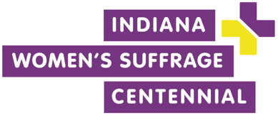

This is a text block. Use it to describe your event. You might highlight the speakers who will appear on your panel, why your organization is planning a field trip to particular location, or information about the content of your exhibit.

This is a good place to let people know the intended audience of your event. For example, you could let people know that your event is free and open to the public.

Insert your logo here

**Wednesday, November 15**

from 6:30 p.m. – 8:30 p.m.

**Location of Your Event**

1500 North Delaware Street

Indianapolis, IN 46202

**Grab people’s attention with this lede or subtitle explaining your event**

Indiana Women’s Suffrage Event Title